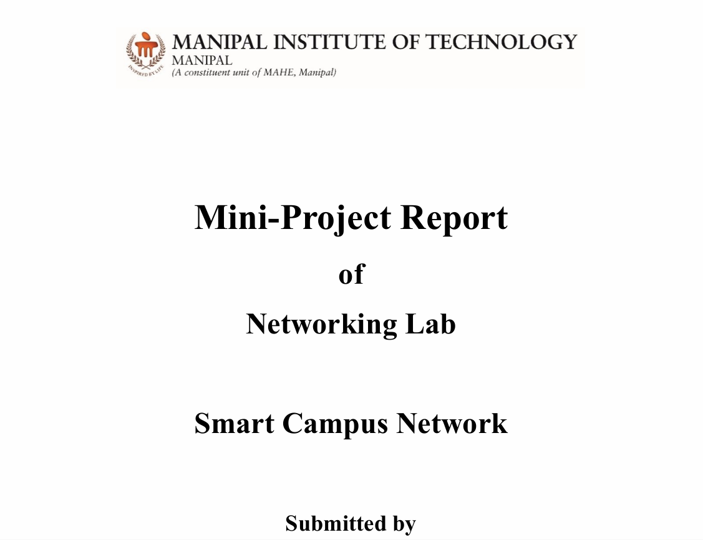

Name | Registration Number | Roll Number
Asmita Bhowmick | 230905100 | 14
Pakhi Agarwal | 230905116 | 16
Princita | 220905115 | 17
Pranav | 230905

School of Computer Engineering Manipal Institute of Technology, Manipal

Acknowledgement
We would like to express our profound and heartfelt gratitude to Dr. Bhukya Padma, Associate Professor, School of Computer Engineering, MIT Manipal for her steadfast support, expert guidance, and constant encouragement throughout the course of the lab and project . Her insightful suggestions, technical acumen, and constructive feedback consistently challenged us to refine our ideas and approach, significantly contributing to the overall quality and depth of our work. Her mentorship has been instrumental not only in the successful execution of this project but also in our academic and professional growth.
We extend our sincere thanks to the School of Computer Engineering, Manipal Institute of Technology, Manipal, for providing us with this enriching opportunity. The resources, infrastructure, and intellectually stimulating environment offered by the department played a crucial role in facilitating the smooth progress of our training. The exposure to real-world problems and advanced methodologies has greatly broadened our understanding of applied computing and research practices.
Special acknowledgement is extended to the developers and contributors of Cisco Packet Tracer and other open-source networking simulation platforms, whose efforts have made advanced network modeling accessible to students, educators, and researchers. The sophisticated simulation tools provided by these platforms formed the technical backbone of this project, enabling accurate design, testing, and analysis of network configurations without any constraints. The dedication of these developers in creating user-friendly, reliable, and educational tools has been instrumental in the successful completion of this work.

INDEX
TOPICS | PAGE NUMBER
Summary | 4
Network Design and Justification | 5
IP Addressing and VLSM Plan | 6
Layer 2 Implementation | 7-8
Layer 3 Implementation | 9-10
Application Layer Services | 11-12
Verification and Testing | 13-24

1. Summary
The Smart Campus Network project was designed and implemented to provide a secure, scalable, and fully functional network infrastructure for a small university environment. The primary objective of this project was to interconnect various blocks of the campus — including the Administrative Block, the Computer Science Department, the Student Hostel, and the Server Block — while ensuring efficient communication, logical segmentation, and network security. The design makes use of Virtual LANs (VLANs) to segregate traffic for each department, reducing broadcast domains and enhancing manageability. Routers were configured using a Router-on-a-Stick approach to enable inter-VLAN routing, ensuring that devices from different departments can communicate through defined gateways. Multiple routers were deployed to provide scalability and redundancy, while the Open Shortest Path First (OSPF) protocol was implemented for dynamic route advertisement and automatic fault recovery across the network.
In addition to network segmentation and routing, the project focuses strongly on security and application-level validation. Port Security was configured on all access ports to limit unauthorized device connections by binding specific MAC addresses dynamically using the sticky feature. This ensures that only known devices can access the network. A Web and DNS server was hosted within the Server VLAN to provide application layer services and to verify full Layer 7 end-to-end connectivity across the network. Comprehensive testing using commands such as ping, traceroute, and show ip route confirmed proper operation of inter-VLAN communication and dynamic routing. The final network achieved all objectives—secure segmentation, fault tolerance, controlled inter-departmental access, and reliable service delivery—demonstrating an effective model of a smart campus network infrastructure.
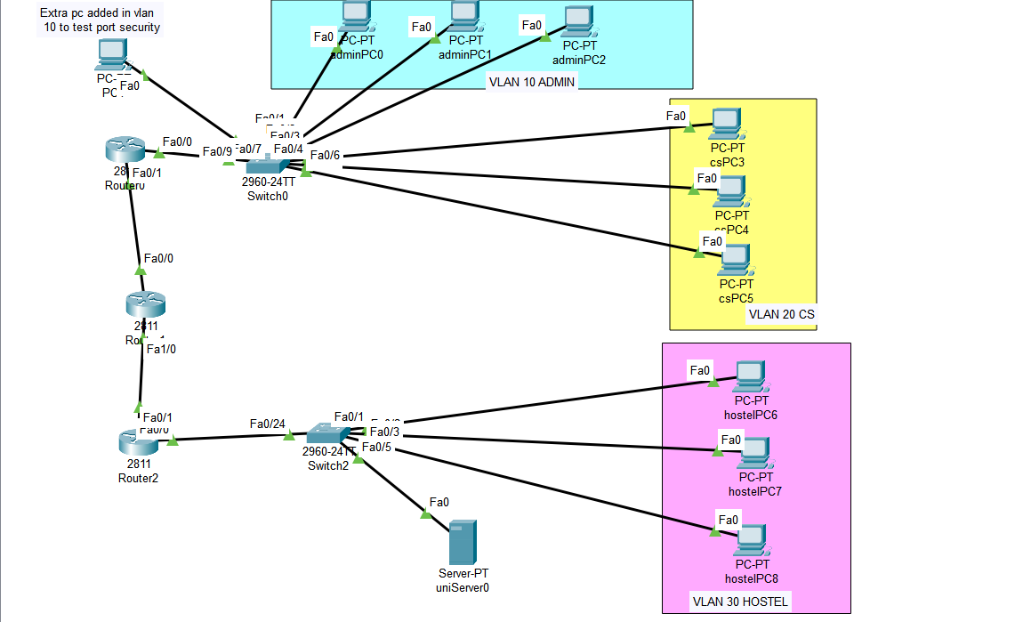

2. Network Design and Justification
2.1 Network Topology
The final topology includes:
- Router0 connected to Switch0 for Admin and CS VLANs
- Router1 connecting the core routers via /30 point-to-point links
- Router2 connected to Switch2 serving Hostel and Server VLANs
- All routers exchange routes dynamically via OSPF Area 0
2.2 Design Justification
Component | Purpose | Explanation
Separate VLANs | Security & segmentation | Prevents broadcast overflow and isolates departments.
Router-on-a-Stick | Inter-VLAN routing | Enables controlled communication between VLANs.
Multiple Routers + OSPF | Scalability & fault tolerance | Each router advertises its connected networks dynamically.
Port Security | Network access control | Restricts each port to one authorized MAC.
Web/DNS Server | Application testing | Confirms L7 functionality.

3. IP Addressing and VLSM Plan
The IP plan follows 10.0.<REG_LAST>.<VLAN_ID>.0/24, where the registration number’s last digits are 00.
VLAN | Department | Network | Subnet Mask | Gateway (Router IP)
10 | Admin | 10.0.10.0 | 255.255.255.0 | 10.0.10.1
20 | CS Dept | 10.0.20.0 | 255.255.255.0 | 10.0.20.1
30 | Hostel | 10.0.30.0 | 255.255.255.0 | 10.0.30.1
40 | Server | 10.0.40.0 | 255.255.255.0 | 10.0.40.1
- | R0–R1 link | 192.168.1.0 | 255.255.255.252 | .1 / .2
- | R1–R2 link | 192.168.2.0 | 255.255.255.252 | .1 / .2

4. Layer 2 Implementation

4.1 VLANs and Trunking
VLANs were created on both switches to segment traffic.
Switch0 Configuration:
vlan 10
name Admin
vlan 20
name CS
interface range fa0/1 - 3
switchport mode access
switchport access vlan 10
interface range fa0/4 - 6
switchport mode access
switchport access vlan 20
interface fa0/7
switchport mode trunk
no shutdown

Switch2 Configuration:
vlan 30
name Hostel
vlan 40
name Server
interface range fa0/1 - 3
switchport mode access
switchport access vlan 30
interface fa0/5
switchport mode access
switchport access vlan 40
interface fa0/24
switchport mode trunk
no shutdown

4.2 Port Security
Each access port was limited to one sticky MAC address.
Example (Switch0):
interface range fa0/1 - 3
switchport port-security
switchport port-security maximum 1
switchport port-security violation shutdown
switchport port-security mac-address sticky
4.3 Verification
show vlan brief
show interfaces trunk
show port-security address

5. Layer 3 Implementation
5.1 Inter-VLAN Routing (Router-on-a-Stick)
Router0 Configuration:
interface fa0/0.10
encapsulation dot1Q 10
ip address 10.0.10.1 255.255.255.0
!
interface fa0/0.20
encapsulation dot1Q 20
ip address 10.0.20.1 255.255.255.0
!
interface fa0/1
ip address 192.168.1.1 255.255.255.252
no shutdown
Router2 Configuration:
interface fa0/0.30
encapsulation dot1Q 30
ip address 10.0.30.1 255.255.255.0
!
interface fa0/0.40
encapsulation dot1Q 40
ip address 10.0.40.1 255.255.255.0
!
interface fa0/1
ip address 192.168.2.2 255.255.255.252
no shutdown

5.2 Dynamic Routing (OSPF)
All routers were configured for OSPF process 1 in Area 0.
Router0:
router ospf 1
network 10.0.10.0 0.0.0.255 area 0
network 10.0.20.0 0.0.0.255 area 0
network 192.168.1.0 0.0.0.3 area 0
Router1:
router ospf 1
network 192.168.1.0 0.0.0.3 area 0
network 192.168.2.0 0.0.0.3 area 0
Router2:
router ospf 1
network 10.0.30.0 0.0.0.255 area 0
network 10.0.40.0 0.0.0.255 area 0
network 192.168.2.0 0.0.0.3 area 0

6. Application Layer Services
Server Configuration
IP Address: 10.0.40.2
Subnet Mask: 255.255.255.0
Default Gateway: 10.0.40.1
DNS Server: 10.0.40.2
Services Enabled:
- HTTP → On
- DNS → On
Record: campus.web → 10.0.40.2
Admin PC (VLAN 10):
IP: 10.0.10.2
Gateway: 10.0.10.1
DNS: 10.0.40.2

End Devices Configuration
Each VLAN has three PCs (for user testing) and one gateway IP on the router.
The server in VLAN 40 provides both Web and DNS services for network-wide access verification.

1) Admin Department – VLAN 10
Network: 10.0.10.0/24
Gateway: 10.0.10.1
Devices:
Device | IP Address | Subnet Mask | Default Gateway | DNS Server
Admin-PC1 | 10.0.10.2 | 255.255.255.0 | 10.0.10.1 | 10.0.40.2
Admin-PC2 | 10.0.10.3 | 255.255.255.0 | 10.0.10.1 | 10.0.40.2
Admin-PC3 | 10.0.10.4 | 255.255.255.0 | 10.0.10.1 | 10.0.40.2

2) Computer Science Department – VLAN 20
Network: 10.0.20.0/24
Gateway: 10.0.20.1
Devices:
Device | IP Address | Subnet Mask | Default Gateway | DNS Server
CS-PC1 | 10.0.20.2 | 255.255.255.0 | 10.0.20.1 | 10.0.40.2
CS-PC2 | 10.0.20.3 | 255.255.255.0 | 10.0.20.1 | 10.0.40.2
CS-PC3 | 10.0.20.4 | 255.255.255.0 | 10.0.20.1 | 10.0.40.2

IP Address: 10.0.20.2
Subnet Mask: 255.255.255.0
Default Gateway: 10.0.20.1
DNS Server: 10.0.40.2

3)Student Hostel – VLAN 30
Network: 10.0.30.0/24
Gateway: 10.0.30.1
Devices:
Device | IP Address | Subnet Mask | Default Gateway | DNS Server
Hostel-PC1 | 10.0.30.2 | 255.255.255.0 | 10.0.30.1 | 10.0.40.2
Hostel-PC2 | 10.0.30.3 | 255.255.255.0 | 10.0.30.1 | 10.0.40.2
Hostel-PC3 | 10.0.30.4 | 255.255.255.0 | 10.0.30.1 | 10.0.40.2

IP Address: 10.0.30.2
Subnet Mask: 255.255.255.0
Default Gateway: 10.0.30.1
DNS Server: 10.0.40.2

7. Verification and Testing T
The network was validated using the following tests. All tests were successful.

• show vlan brief: Confirmed correct ports were assigned to correct VLANs on both switches.

S0>CLI
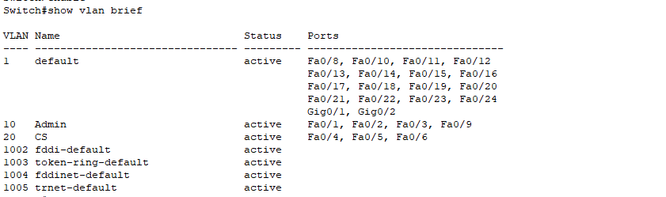

S2>CLI
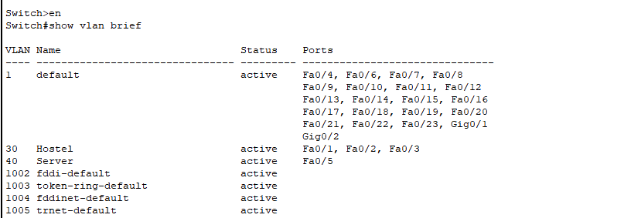

- Show trunk verification:
S0>CLI
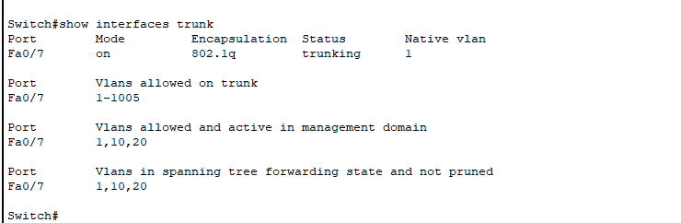

S2>CLI
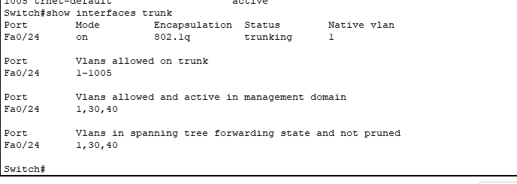

- Port security address:
S0>CLI
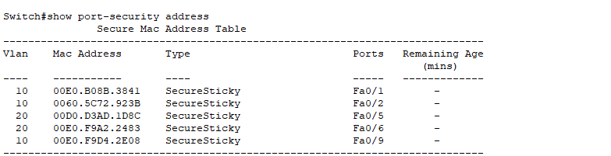

S2>CLI
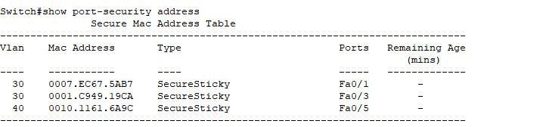

- Router subinterfaces
R0:
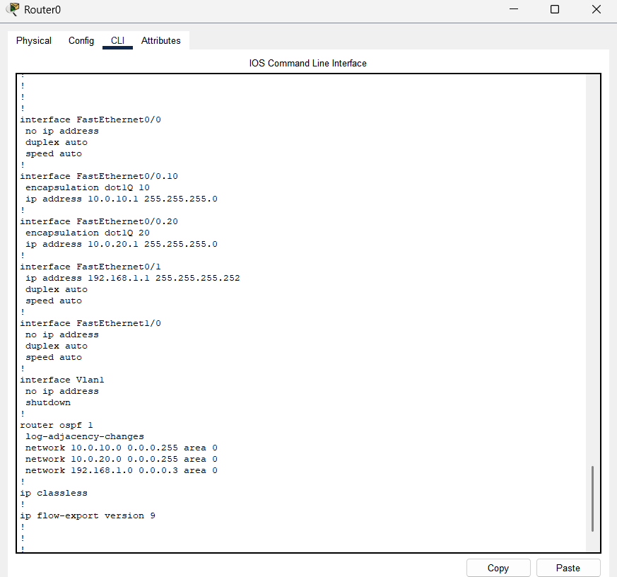

R1:
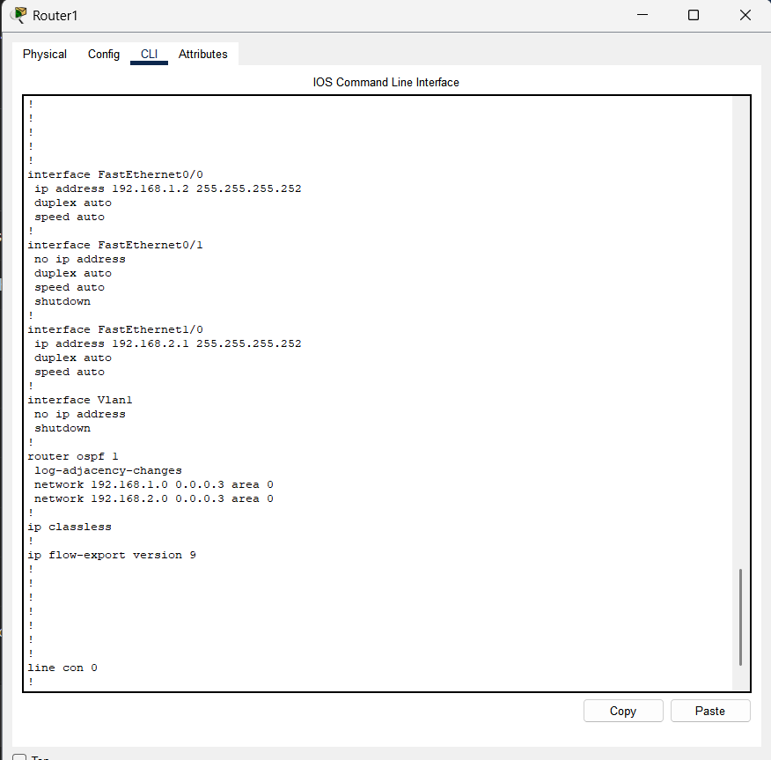

R2:
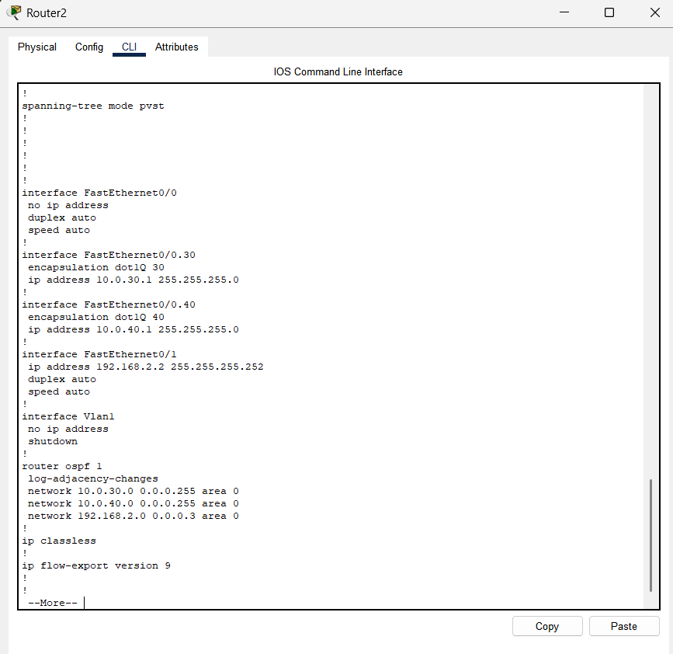

- OSPF Neighbors:

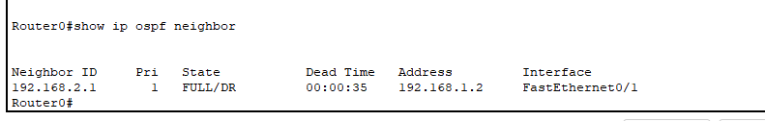

R1:
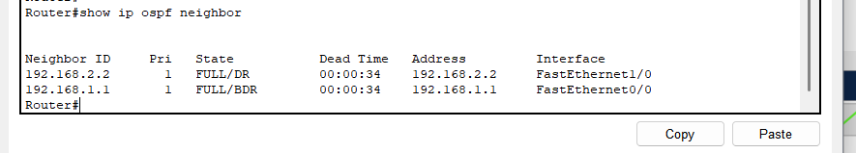

R2:
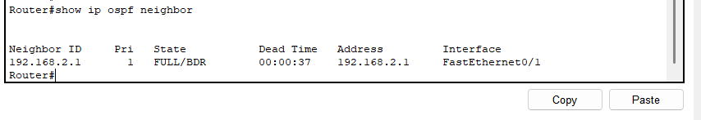

- Routing table

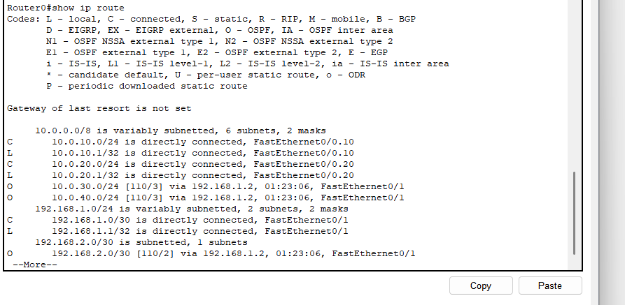

R1:
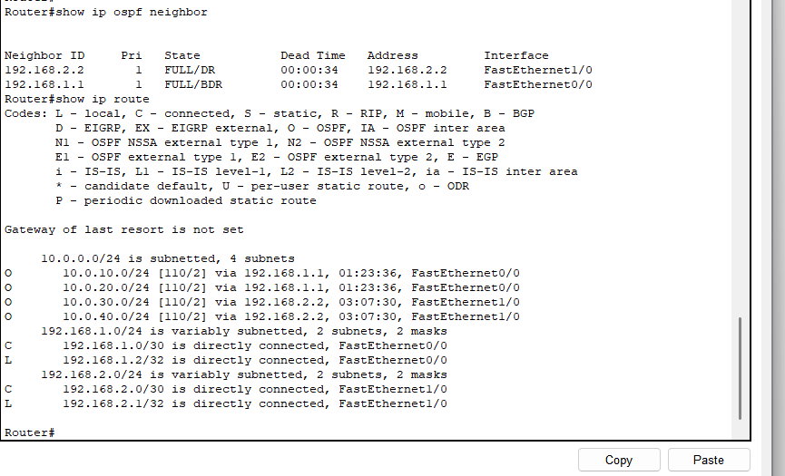

R2:
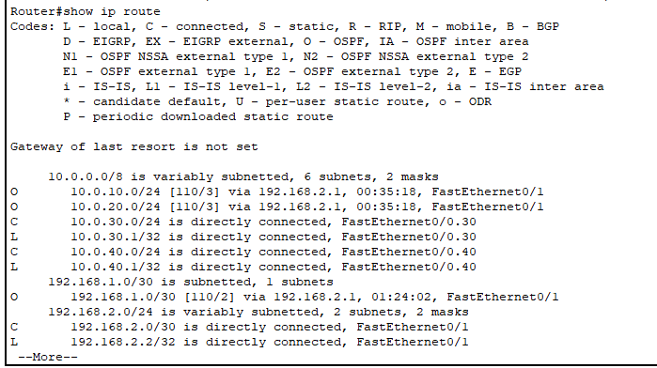

- Pinging test:
1)Within Vlan:
(Admin Vlan)
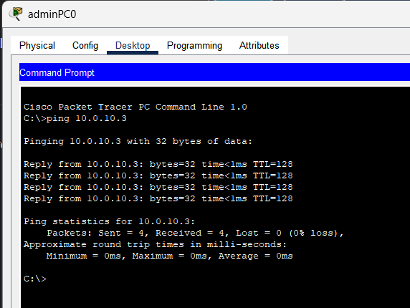

2) Between Admin VLAN and CS VLAN(Inter-vlan)
P0:
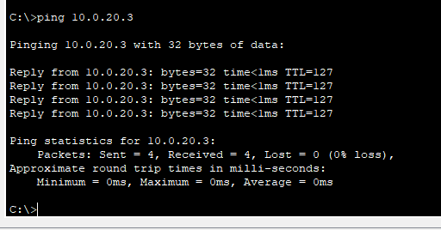

3)Between Admin and Hostel (inter Vlan)
PC0:
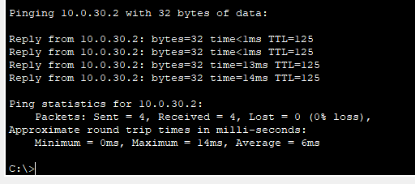

- HTTP server testing
PC0:
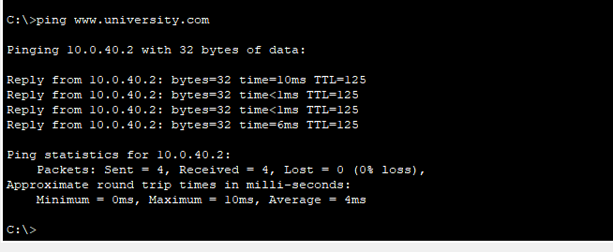
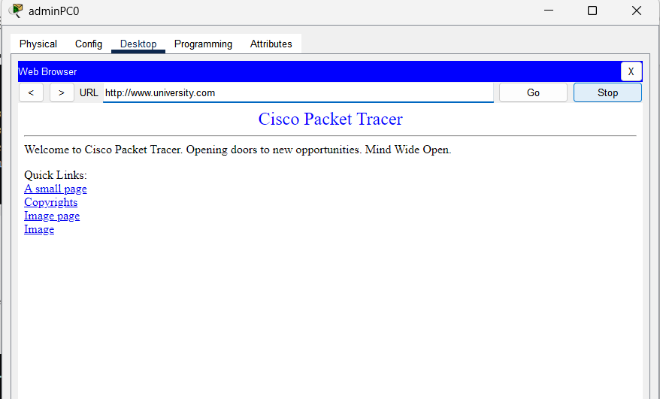
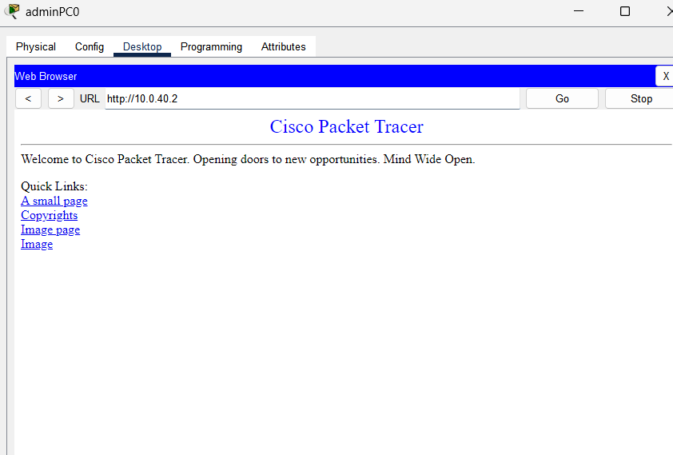

- . Security Test: Port Security Violation
This test verifies that Port Security is active and restricting unauthorised devices. 1. Action: A new, unauthorised PC was connected to SW0's Fa0/9

Test: ping 10.0.10.2 from the unauthorised PC.

Result: Ping FAILED.

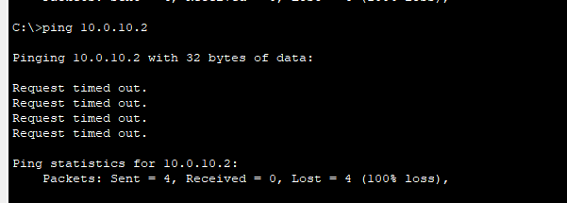

Verification:
Show port-security interface Fa0/9 on SW0 confirmed:
◦ Port Status: Secure-up
◦ Violation Mode: Restrict
◦ Security Violation Count: 5

